Project 3 - API Integration - Team 21

Hunter Cleary, Chris McLean, Daniel Trejo

**Initial Prototype Documentation**

**Goal**

The goal of the project is to create a more intelligent search tool that will show the user information on the keyword input and accompanying info on its trendability. The final screen shown to the user will show the definition snippet related to their keyword and clear visualizations of when/where/how it is trending.

**Scope**

An achievable goal would be to create the system, with a intermediary “context” page included, allowing the user to select the exact connotation of their keyword input. If this is deemed to be too much, the fallback goal would be to implement the system without the “context” functionality. If the “context” functionality is complete and working with extra time to spare, stretch goals would include graph interaction, photo presentation, and working links to related “trendfo” stat pages.

**APIs Being Used**

The wikipedia API is being used to obtain a definition snippet to present to the user. Wikipedia will also be used to find the corresponding / related topics that can be presented to the user.

The google trends API is being used to showcase how the keyword is being used or referenced in the real world and online. Being able to see geographically where something is popular, or when something started to gain traction in the public mind will be very useful.

The google visualization API will be used to display the information that is retrieved using the google trends API. Puttin the information into clear and informative graphs will benefit the experience of the user.

**Possible Use Cases**

A student doesn’t know where to start on a research paper. They have a topic, but not enough time to search through score of pages to find relevant related topics and information. Using trendfo, they could find out information about the initial topic as well as other related items and how they are in relation.

A young entrepreneur is interested in opening a store that sells “insert item here”. Using trendfo, they could find if people have been searching for that specific item in an area , along with related items that potential customers might be interested in purchasing.

**Development Challenges**

There may be some difficulty judging in which context the trend graphs should be shown. It wouldn’t be beneficial to the user to see uninformative trend data, no matter how clairvoyantly it is presented.

**Organization Plan**

With the general GUI already set up, each team member will select one of the three APIs to begin work on. When each member has the API working with sample / test cases. The team will come together to decide how they will be connected to form a final product. As the processes are connected, the GUI will be tidied up. And the members can work remotely to clean up small issues. User testing should bring up any clear issues that can be taken care of before release.

**Interface Sketch**

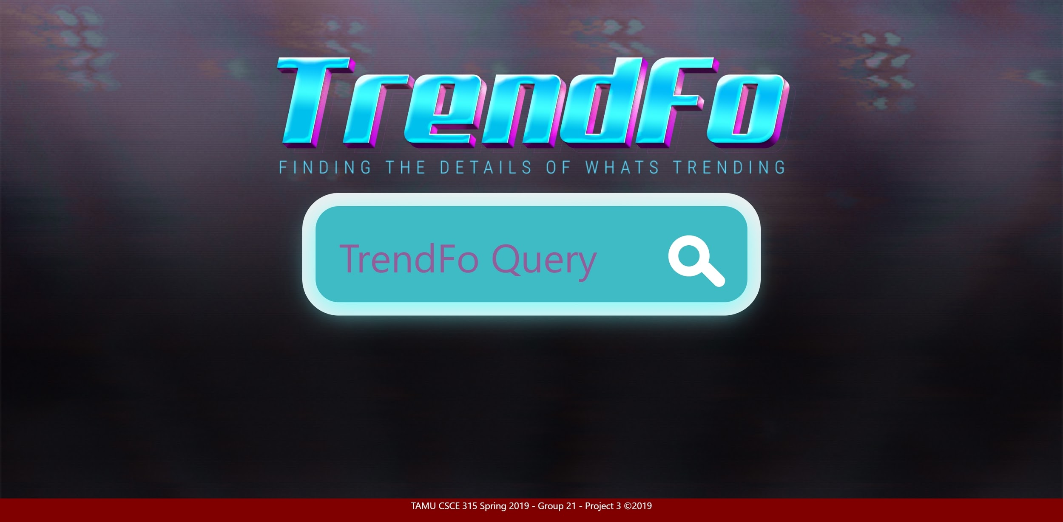

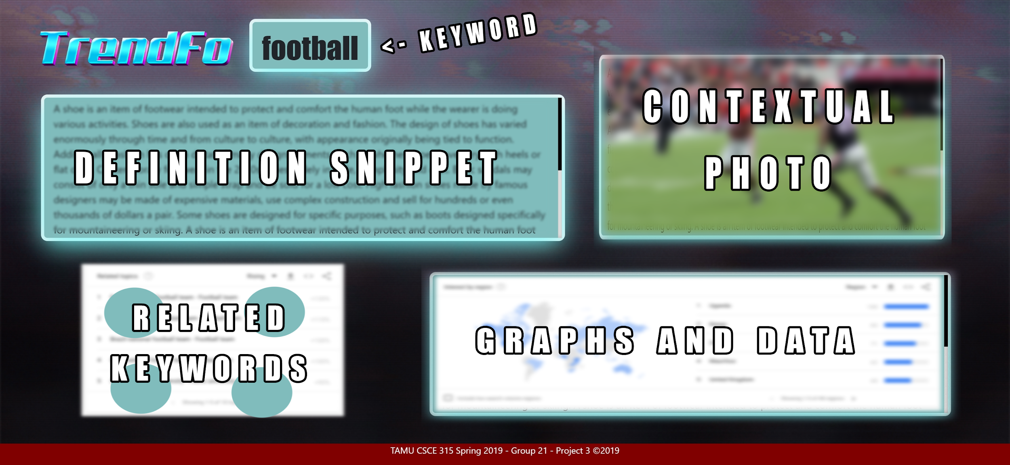

**Source Code Submission**

Code is not expected to be functional

Just enough to do the user study